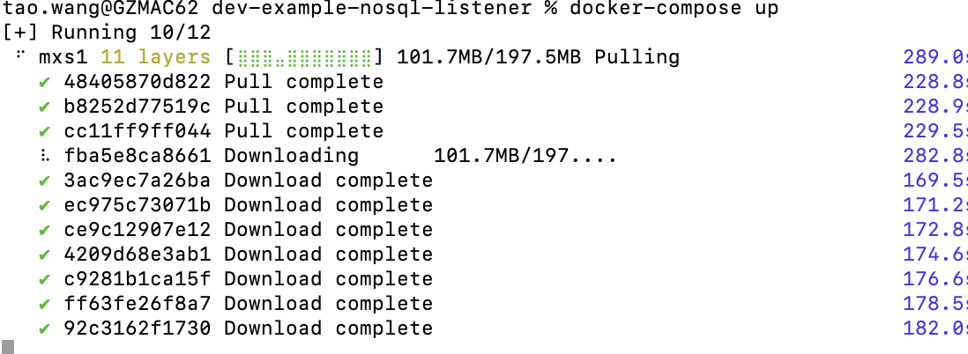

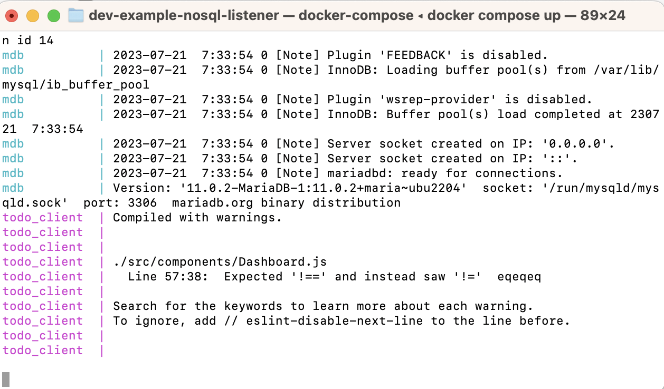

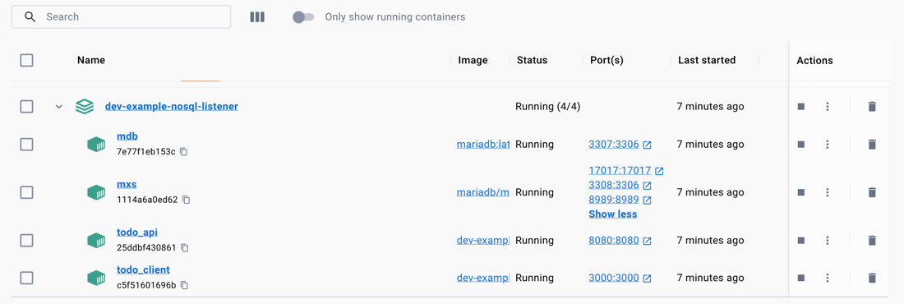

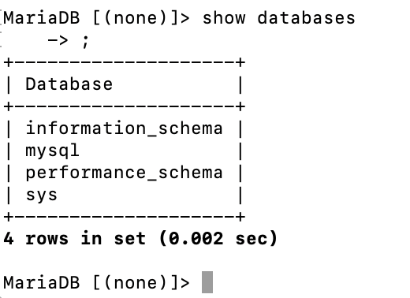

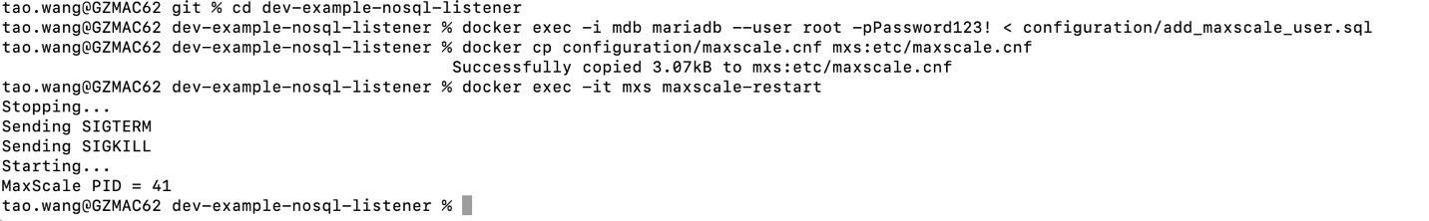

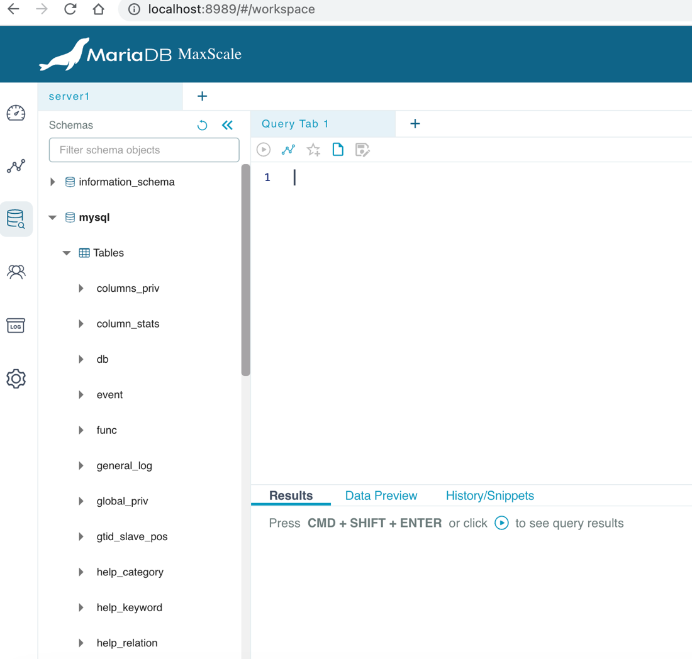

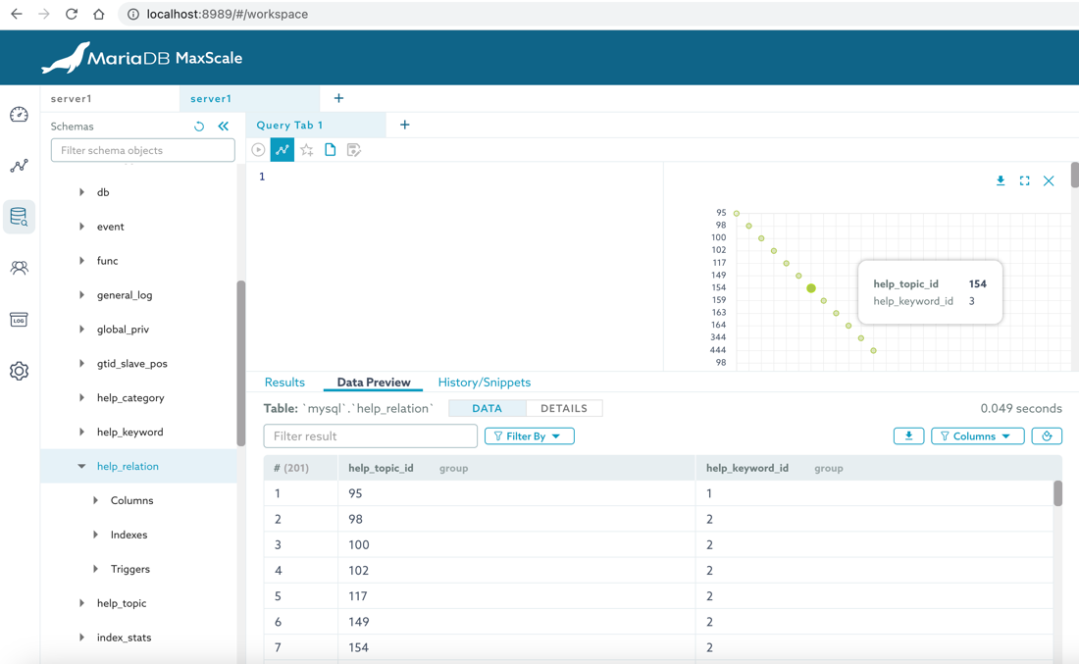

<http://localhost:8989/#/workspace>

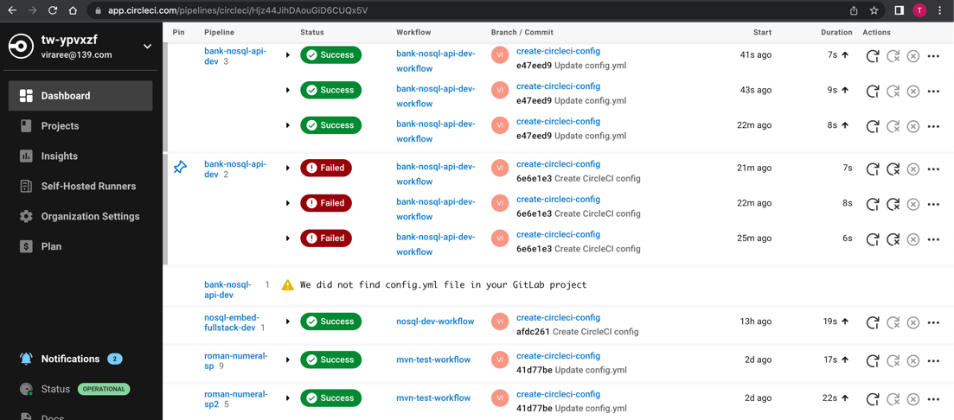

<http://localhost:3030/api>

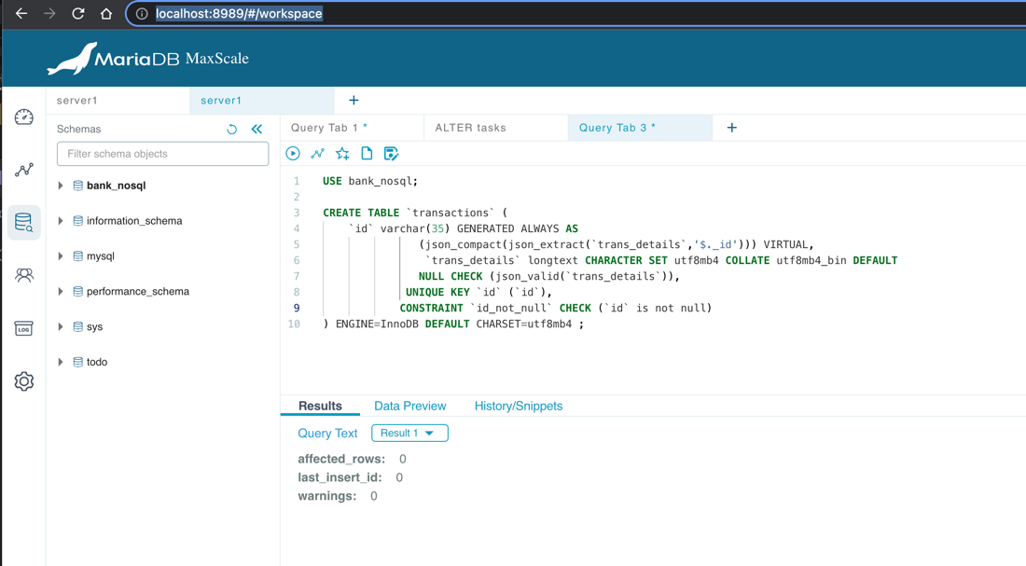

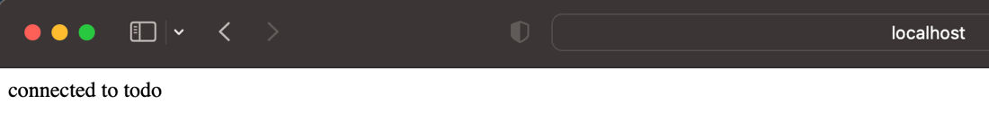

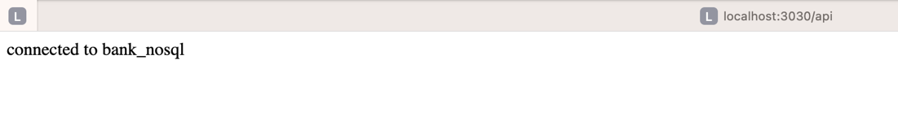

<https://app.swaggerhub.com/apis/VIRAREE_1/BankTransaction/1.0.0>

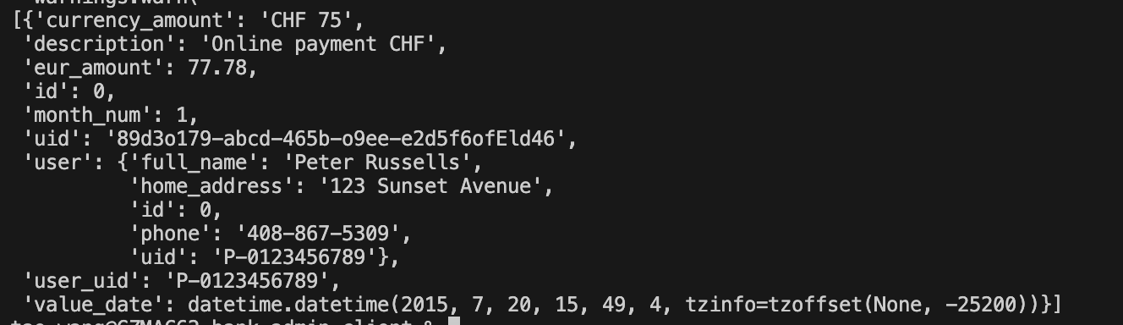



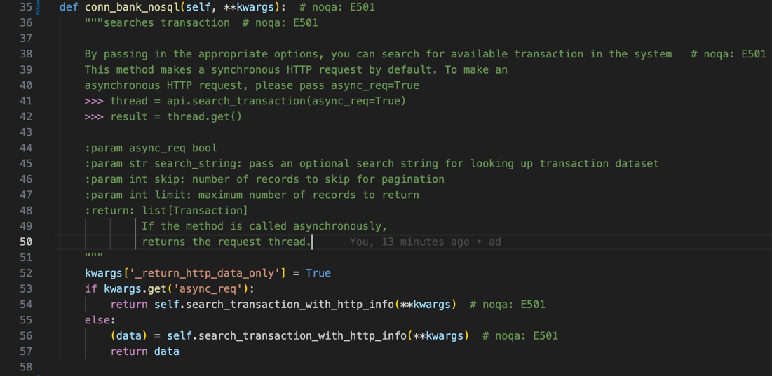

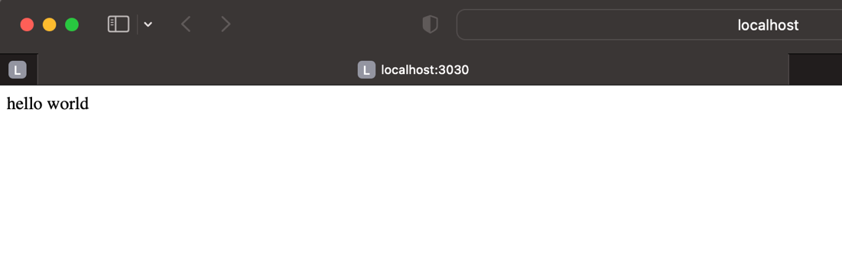

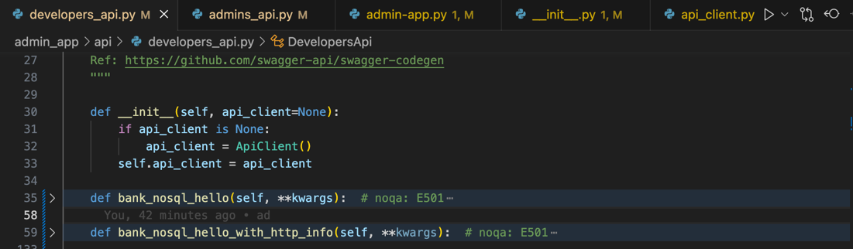

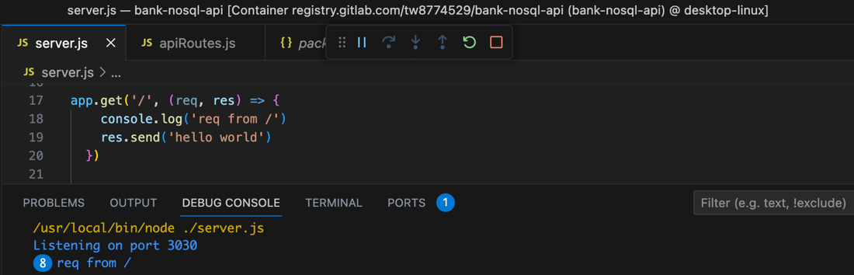

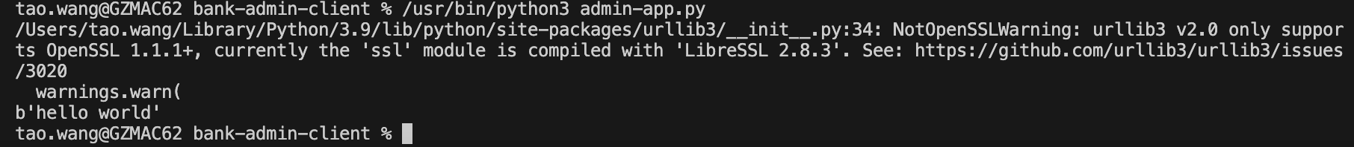

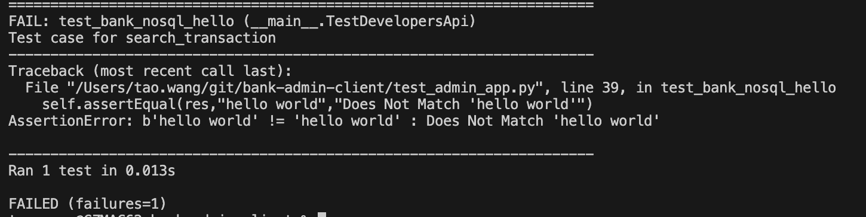

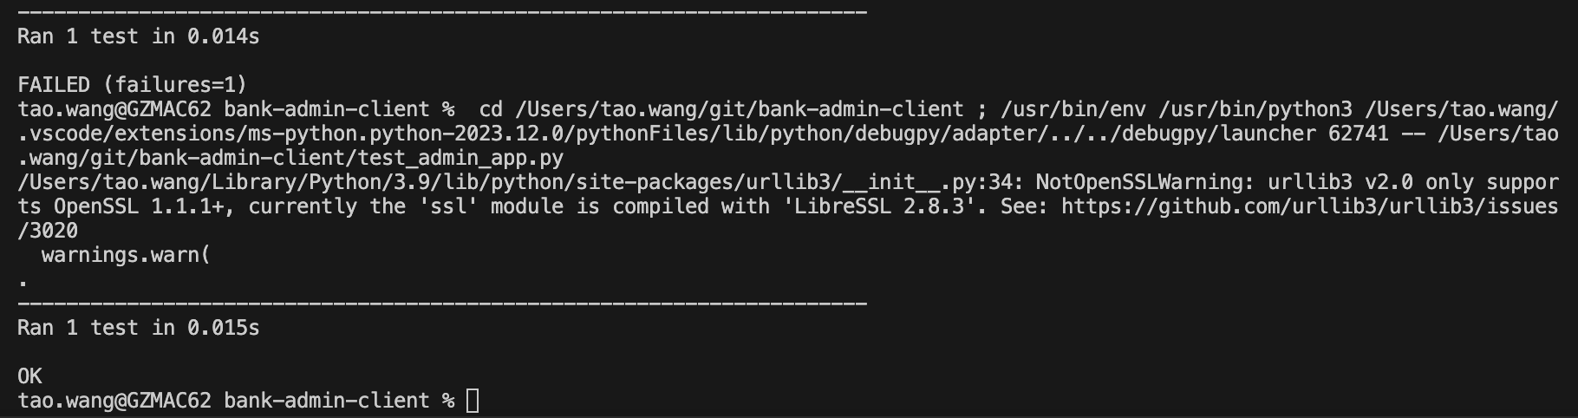



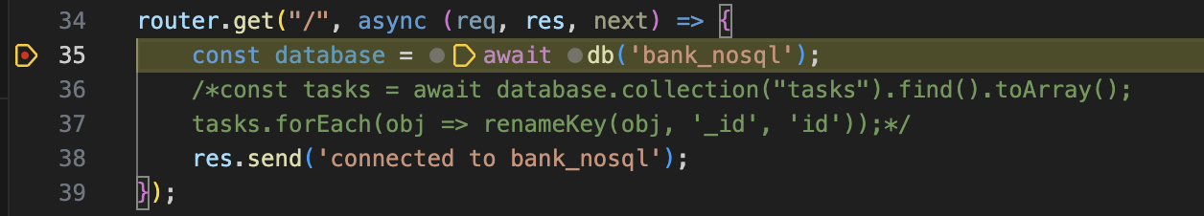



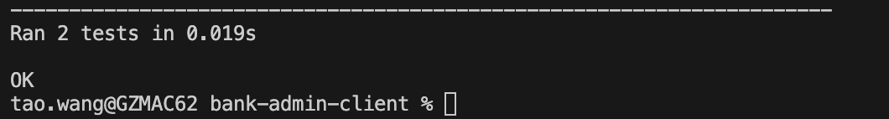

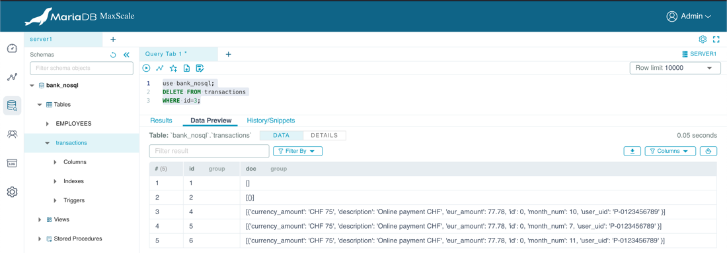

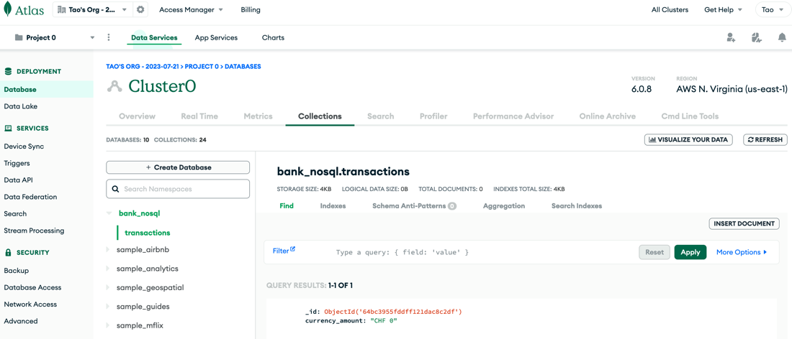

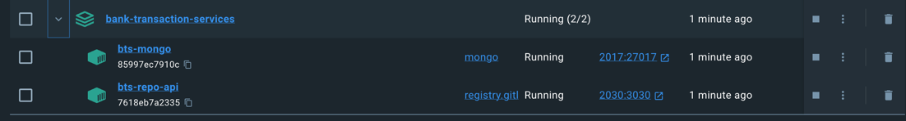

![I {"t" : {"$date" "s" : "1", "REPL" , 
bts—mongo 
atue" , "att r" : {"featureCompatibi tityVersion" : "6. , "context" : "startup"}} 
PROBLEMS OUTPUT 
DEBUG CONSOLE 
TERMINAL 
bts—repo—api I Listening on port 8080 
":47959Ø6, 
"RECOVERY", 
W' 
"ctx":" initandlisten" , "msg" : "Clearing temp directory"} 
"c": "STORAGE", 
" C" : "REPL 
" ctx'i:" initandlisten" , "msg": "Timestamp monitor starting"} 
GITLENS 
> zsh - bank-transaction-services 
x 
I "c": "STORAGE , 
bts-mongo 
it Us": 989}} 
I : {"$date" øø"}, "s" 
bts-mongo 
{" recoveryTimestamp" : $timestamp" : {"t" : , " i" : 
I " " % "CONTROL", 
bts-mongo 
S 
database. Read and write access to data and configuration is ["startupWarnings"]} 
I {"t" "s" : "CONTROL", " id" :51233øø, "ctx 
bts-mongo 
"currentVatue" : 262144, " recommendedMinimum" : 1677720 , "maxConns" : , "tags" : sta rtupWa rnings" ] } 
I : "s" : "NETWORK", "id" :4915702, "ctx 
bts-mongo 
oldSpec" : {" incomingExternalClient" : {"minWireVersion" : 0, "maxWi reVersion" : 17}, " incomingInternalClient" : {"minWireVersion" : 0, "maxWi reVersion" : 17}, "outgoing" : {"minWi reVersion 
" : 6, "maxWi reVersion" : 17}, " islnternatCtient" : true} , "newSpec" : incomingExternatCtient" : {"minWireVersion" : O, "maxWireVersion" : 17}, " incomingInternatClient" : {"minWireVersion" 
: 17 , "maxWireVersion" : 17}, "outgoing" : {"minWi reversion" : 17 , "maxWireVersion" : 17} , " islnternalClient" : true}}} 
" ctx" : "initandlisten" , "msg" : "WiredTiger opened" , "attr" : {"durationM 
" ctx" : " initandlisten" , "msg" : "WiredTiger recoveryTimestamp" , "attr" : 
"ctx••:" initandlisten" , "msg": "Access control is not enabled for the 
, is too low" , "attr" :{ 
" : " initandlisten" , "msg" : "Updated wire specification" , "attr" : 
bts-mongo 
bts—mongo 
yment"} 
bts-mongo 
bts-mongo 
r" : {" newState" : "Conf igReplicationDisabled" , "oldState" : "Conf igPreSta rt" 
I "s" : " c" : "STORAGE", 
bts-mongo 
I "NETWORK", 
bts-mongo 
odb-27Ø17. sock"}} 
I : {"$date" : "s" : "1" , 
I {"t" "c": "CONTROL", "id":2Ø536, 
I {"t" : {"$date" "FTDC" 
a capture" , "attr" : {"dataDirectory" : "/data/db/diagnostic.data"}} 
I : {"$date" : "s" : "1" , 
"id" : 58533øø, 
" id" : 6015317 , 
"ctx":" initandlisten" , "msg": "current featureCompatibilityVersion v 
"ctx":" initandlisten" , Control is enabled on this deplo 
, "msg" : "Initializing full—time diagnostic dat 
"ctx":" initandlisten" , "msg": "Setting new configuration state" , "att 
" ctx" : " listener" , "msg" : "Listening on" , "attr" : {"address" : "/tmp/mong ](

